
STUDENT ID | 2403018
NAME | Carl Gardiner
WORKPLACE | Ordnance Survey
ACADEMIC SUPERVISOR | Peter Lewis
WORKPLACE SUPERVISOR | Tom Prutz

PROJECT TITLE

Data Seeding Script for Development Environment Deployments

Contents
Introduction 1
Justification of the project 2
Discussion of the Problem 2
Discussion of the Potential Resolutions 5
Discussion of the Benefit of the Project to Ordnance Survey 5
Cost 5
Flexibility in Environments 6
Better Developer Experience 6
Better Developer Productivity 6
Greater Feedback for Breaking Changes 7
Better Disaster Recovery Response 7
Discussion of the Benefit to Me in Terms of Career Goals 7
Discussion of the Anticipated Mapping to Occupational Themes and Associated KSBs 8
General KSBs 8
Knowledges 8
Skills 9
Behaviours 10
Software Engineer KSBs 11
Knowledges 11
Skills 13
Requirements and Objectives 15
Functional Requirements 15
Non-functional Requirements 15
Security Requirements 15
Objectives 16
Success criteria 17
Resources 18
References 20
Appendices 21
Appendix A – Project Plan 21
Appendix B –Risk Assessment 22
Appendix C – Ethics Statement 23
Appendix D – Declarations and approval signatures 25

List of Figures
Figure 1 - How ACES Works 3
Figure 2 - New Service Deployment Pipelines 4
Figure 3 - Deployment Pipeline and Timing 4
Figure 4 - Azure Cost for Development Environment 6

List of tables
Table 1 - General Knowledge 9
Table 2 - General Skills 10
Table 3 - General Behaviours 11
Table 4 - Software Engineer Knowledges 12
Table 5 - Software Engineer Skills 14
Table 6 - Functional Requirements 15
Table 7 - Non-functional Requirements 15
Table 8 - Security Requirements 16
Table 9 - Objectives 16
Table 10 - Success Criteria 17
Table 11 – Resources 19
Table 12 - Risk Assessment 22

Introduction
At Ordnance Survey, there is a general push towards flexibility, repeatability and consistency in development and testing environments to save on costs, reduce development time, improve disaster recovery metrics and improve developer experience. This is being done by exchanging a legacy cloud environment provisioning system, ACES (Azure Configuration Environment Service), for a more modern and idiomatic way of using Azure subscriptions.
This project is part of this push and involves the creation a script that seeds data into a SQL database and blob storage in Azure. This script is to be run as part of a deployment pipeline which creates new development and testing environments for a service called Errors and Omissions. The creation of this script will allow these newly created environments to have test data available at creation time. It is hoped this capability will make our development and testing environments cheaper, easier to restore and will improve development and testing capacity and velocity.

Justification of the project

Discussion of the Problem
At Ordnance Survey, Azure is used as the cloud platform for deploying services. At times, there is a need to have multiple development or testing environments for a service running concurrently. This is because multiple developers may be working on the same service, and changes to code, infrastructure or data made by one developer may negatively impact the ability of other developers to get their work done. At other times, only a single development or testing environment would be sufficient.
Furthermore, it would occasionally be beneficial to remove development and testing environments entirely, to save on costs. Examples of times when this would occur is when mature services are in production and are not being actively developed for and over Christmas break, when the only work done is incident response by on-call engineers. Removing development and testing environments entirely would also force Ordnance Survey to have deployment pipelines to deploy a development or testing environment from scratch. This would benefit Ordnance Survey’s disaster recovery strategy in part as, at least for development and testing environments, infrastructure could be redeployed “to a known good state as defined in the repository, drastically reducing downtime and the complexity often associated with recovery processes” (Libro & Lajko, 2024).
The ability to quickly create and remove development and testing environments would also help Ordnance Survey conform to ISO27001, as this would implement ISO 27001:2022 Annex A 8.31 which states “Organisations should establish suitable protocols and regulations to firmly separate development, testing, and production settings in order to eradicate security hazards” (Whiting, 2025).
Currently, Ordnance Survey manages subscriptions and resource groups in Azure through ACES. This system operates by referencing a collection of JSON files internally known as deployment profiles. Each system code (essentially a way of tracking cost per team or service) has its own deployment profile and resource groups are deployed into the subscriptions a deployment profile will specify in the deployment profile. This means that subscriptions have resource groups from multiple different teams and services across Ordnance Survey, as multiple different deployment profiles can reference that their resource groups should be in the same subscriptions as other deployment profiles. This is not the intended purpose of subscriptions, as subscriptions are intended to be used as financial containers for resources, as “Billing for Azure resources is done on a per-subscription basis. An Azure subscription defines a set of Azure resources that are invoiced together” (Microsoft Learn, 2026).
Ordnance Survey’s current use of subscriptions and resource groups also often leads to the limit of 980 resource groups in a subscription being hit (Microsoft Learn, 2026), leading to stalled operations across the business as new subscriptions need to be created to accommodate more resource groups.
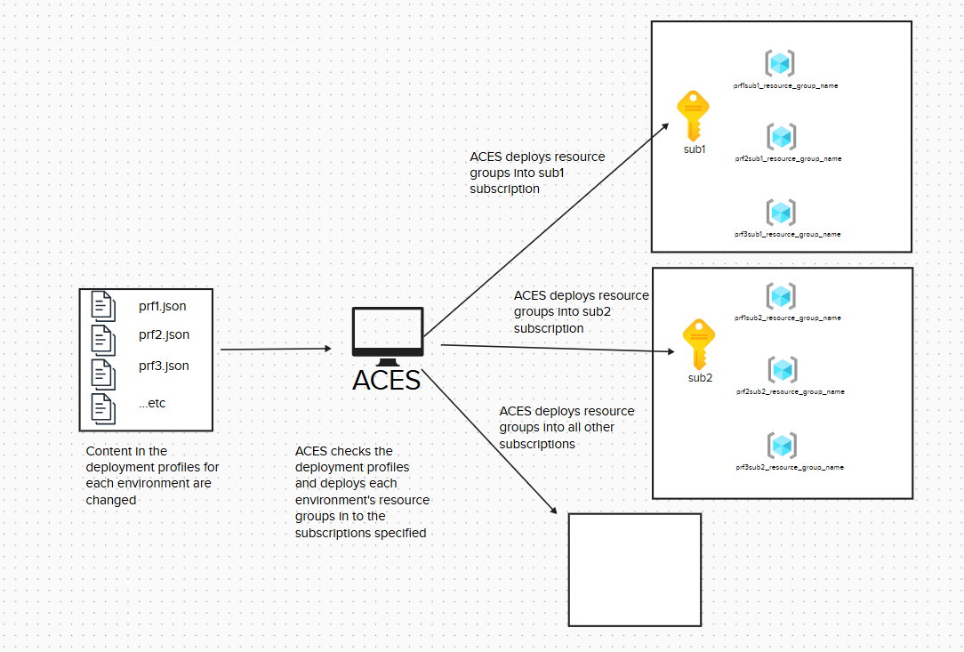
Figure 1 - How ACES Works
The biggest problem with ACES, though, is that it does not allow for easy deployment and teardown of environments that developers need to work effectively. For starters, it checks every deployment profile and then deploys or removes resource groups based on these deployment profiles. Some deployment profiles for certain system codes have gotten too large and can run for up to 4 hours before deploying a new resource group. As one of the benefits of the cloud is the ability to “quickly spin up and tear down test environments, making more efficient use of resources” (Andersson, 2023), this slowness to deploy resource groups is unacceptable as the benefit of quicker development are lost. The other side to this is that unneeded resource groups would be slow to teardown, leading to the unnecessary resource groups being left up (affecting the cap on resource groups in a subscription spoken of previously) and potentially resources being left up that lead to increased cloud costs. ACES also does not by itself create resources in the resource groups, merely the resource groups themselves along with some networking components.
To combat this, new subscriptions outside the ACES system have been set up for some new services. Each subscription is named after the service it contains (acting as a billing bucket) and the type of environments it has in it. For example, one subscription may be for the production environment of Service A, whereas another subscription would be for the development and testing environments of Service A.
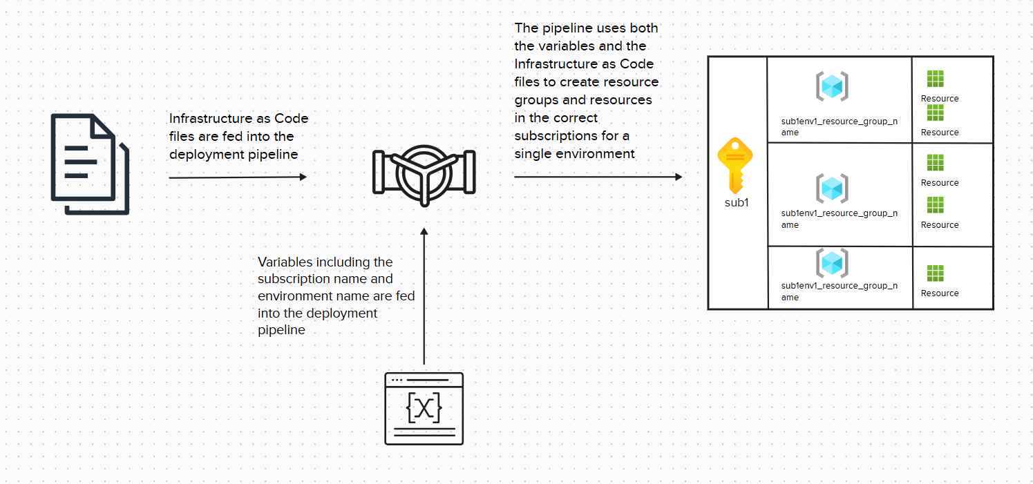
Figure 2 - New Service Deployment Pipelines
Currently, new deployment pipelines have been created in Azure DevOps that can create development and testing resource groups in one of our development and testing subscriptions for a service called Errors and Omissions. So far, most of the infrastructure of the new service has been created, with key vaults, databases, backend APIs, event grids and network rules being deployed into their own resource groups. Currently, these pipelines run for about 15-16 minutes on average for a full deployment (see Figure 3 below) making deployment significantly faster than ACES. However, one of the frontend systems is still in local development, and no data is placed into the database upon creation, meaning that the system cannot be useful for development and testing in its current state.
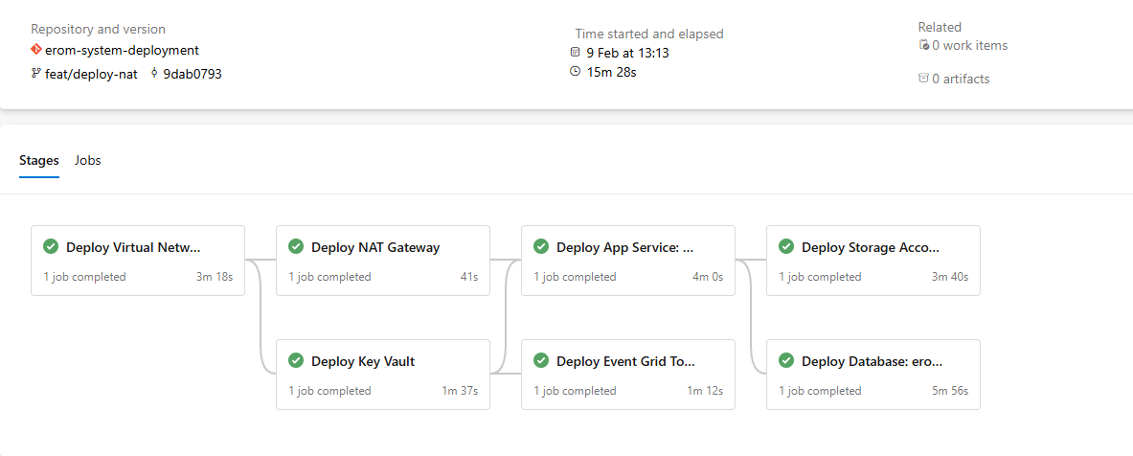
Figure 3 - Deployment Pipeline and Timing

Discussion of the Potential Resolutions
To rectify this, the idea is to add a stage to the deployment pipeline for development and testing environments. This stage will seed data into the SQL database and blob storage. This will allow for development and testing work in these environments upon their creation. To do this, a PowerShell script will be created which will interact with the database, seeding valid records into the database initially, and then placing attachments in the blob storage. The blob storage is where images (known as attachments) that are referenced by a record in the SQL database go. As such, they need to be seeded after the initial database records are seeded.
These seeded records need to be valid and reflect real-world production records, as they may be used for future unit and manual testing in the pipeline and “High-quality, realistic data lays the essential groundwork for understanding how the system will truly behave once deployed in a live production environment. This is crucial for enabling developers to make informed design decisions and foresee potential pitfalls or issues early in the development life cycle” (Cowell & Malmqvist, 2024).
During this, the goal is to not allow for the seeding script to run for a long time, so the time taken for the script to run should not make the overall run of the pipeline take much longer than the roughly 15-16 minutes that it currently takes. This is because one of the goals of the move away from ACES was to decrease the amount of time it takes to provision development and testing environments and adding a long-running script would nullify this.
This project will not involve the deployment to production, as there are significant safeguards that need to be implemented there, and currently there is no production environment for the Errors and Omissions service in its current form.

Discussion of the Benefit of the Project to Ordnance Survey

Cost
The ability to quickly deploy functional development and testing environments with valid and useful data means that the inverse is also true: that environments are transient and can be torn down when not in use. This would lead to a reduction in costs when development and testing is not being done on a service, as these environments could be torn down completely, reducing cloud spend in Azure. Traditionally, resource groups have been left up, with databases containing data, because there weren’t scripts to seed the data, leading to larger cloud costs. Currently, before implementation of the data seeding script, the cost of a single environment for the service the data seeding script is associated with split across multiple resource groups in a subscription is expected to cost around £1459.07 per month.
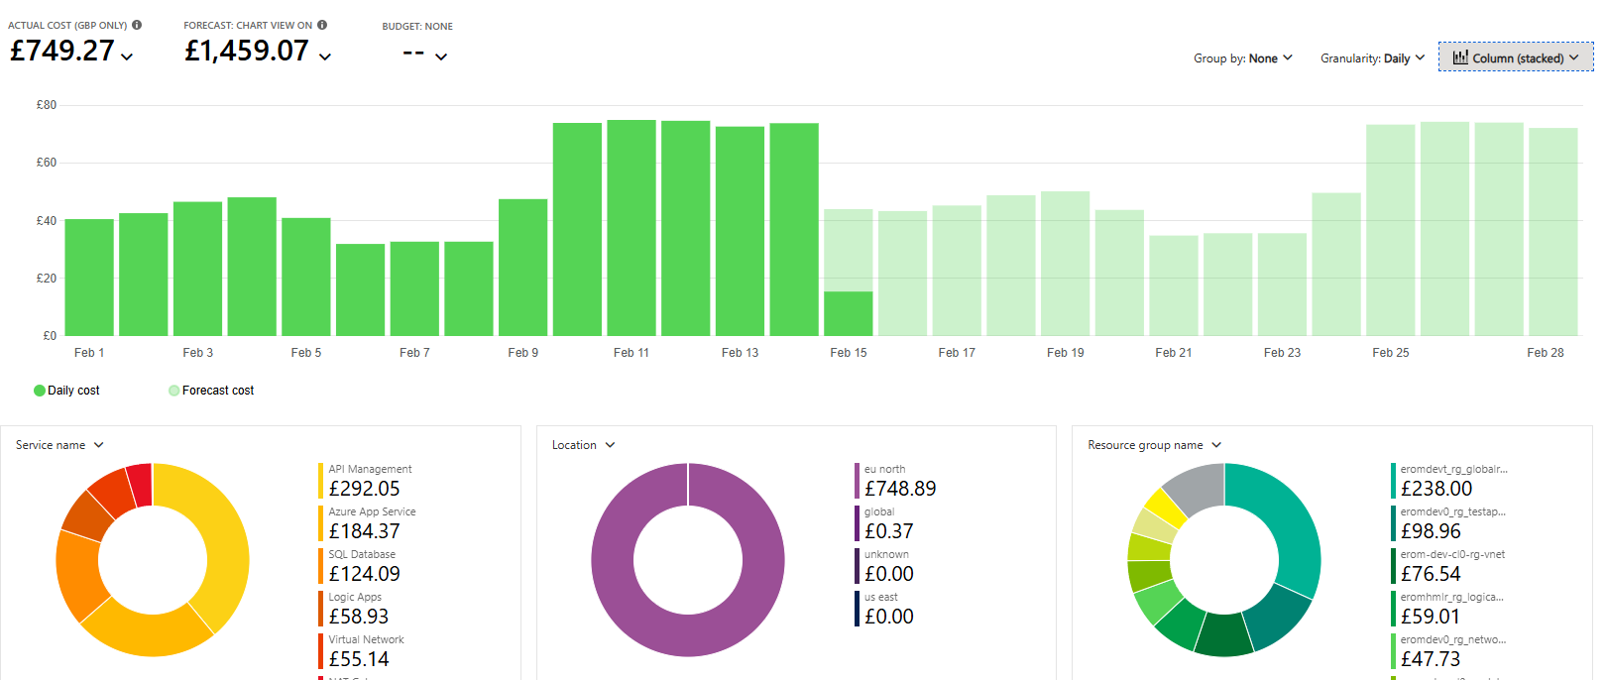
Figure 4 - Azure Cost for Development Environment

Flexibility in Environments
The ability to use the new subscription model successfully by having fully functional development and testing environments will allow for better flexibility in the future. Currently, ACES provisions resource groups in a way that is quite inflexible. If it is possible to setup the environments to work properly, with valid data seeded into their databases and storage accounts, then movement to the new subscription model could be approved for more services, allowing for greater control of development teams over their resources, increasing how flexible infrastructure can be, allowing for services to fit specific use cases better.
The creation of the data seeding script would also allow for the containerisation of the Errors and Omissions service in the future. Containerisation would allow for better testing for the Errors and Omissions service, as “Testing teams benefit from disposable and reproducible environments, where new test cases can be executed in isolated, clean containers without the risk of conflicts” (Green, 2025).

Better Developer Experience
Being able to segregate development and testing environments per developer will prevent developers from accidentally interfering with other developer’s work. In combination with source control through Git, developers will be able to make changes to code, infrastructure and data without impacting other developers. As “developers spend an estimated 20% to 60% of their time integrating and managing infrastructure” (Buchanan, 2025), segregated environment would hopefully reduce these percentages, allowing for potentially multiple days’ worth of development time to be regained per week for each developer.

Better Developer Productivity
Because developers will not be impacting each other, developers should be able to be more productive, without having to account for changes other developers are making.
“When a project is working on multiple streams of functionality, it can sometimes be beneficial to split the development environments, allowing different teams to work on their own functional area, unit testing, and deploying as and when the features become available” (Herrera, 2022).

Greater Feedback for Breaking Changes
Having valid data already seeded in the databases and storage accounts will allow developers to get real time feedback when changes they have made cause problems on the frontend or backend of services.

Better Disaster Recovery Response
Having valid data already seeded in the databases will allow the team to replicate development and testing environments more quickly. This capability will help Ordnance Survery’s Disaster Recovery response as making sure that our development and testing deployment pipelines work from scratch, with the records placed in the databases and blob storages essentially acting as IaC (Infrastructure as Code). This IaC code can be reused for production deployments, removing manual construction of any production environment. Because manual setup often introduces configuration drift between environments, which “hampers the testing of changes and undermines confidence in the safety of deploying them to a production system" (Garverick, et al., 2023). Running IaC driven deployment pipelines in development and testing environments which will later be reused in the production environment will give Ordnance Survey more confidence in the ability to redeploy Errors and Omissions to production in a Disaster Recovery scenario.

Discussion of the Benefit to Me in Terms of Career Goals
Creating the data seeding script will give me a greater understanding of Azure. It will also help me to have more knowledge of relational databases (through interaction with the SQL database) and non-relational databases (through interaction with the Azure blob storage).
I will also have a better understanding of DevOps practices by using Azure DevOps and Azure DevOps pipelines to seed the data.
I will have a better understanding of our system’s architecture, as I will need to add the data seeding script to an already existing deployment pipeline and will have to use version control through Git to achieve this.
I will also benefit as the quick deployment of development environments will be beneficial to me in the future, allowing me to work in my own segregated environment, unobstructed by changes made by other developers.
I will also become more familiar with PowerShell scripting through the creation of this data seeding script.
It will also show Ordnance Survey that I am able to pioneer novel work, as the data seeding script is supporting the new proof-of-concept way of working with subscriptions.

Discussion of the Anticipated Mapping to Occupational Themes and Associated KSBs

General KSBs

Knowledges
KSB | Description | How this KSB will be achieved
K3 | Principles of estimating the risks and opportunities of digital and technology solutions. | This will be achieved by identifying the security and productivity risks inherent in extending the pipeline and seeding data in the database. These risks include extending the duration of the pipeline significantly which will impact developer productivity in the future and the security risks of interacting with the SQL database and storage account through a PowerShell script. The considerations of either causing the PowerShell script to interact with the already provisioned API or giving the script access to the database and storage account directly both expose some degree of access to the cloud storage in Azure.
K4 | Techniques and approaches involved in creating a business case for new digital and technology solutions. For example, journey, product and capability mapping and value chains. | This will be achieved by considering how the addition of a data seeding script can provide better development environments through Ordnance Survey’s new approach to Azure subscriptions and resource groups. This will allow for more features to be delivered faster for the customer.
K5 | A range of digital technology solution development techniques and tools. | This will be achieved by programming PowerShell scripts, rewriting some Azure DevOps pipelines, interacting with cloud storage and using version control through Git.
K15 | Principles of estimating cost, and time resource constraints within digital and technology solutions activities. | This will be achieved by using a Gantt chart to estimate the time the project will take and tracking the progress of the project using logbooks. Estimation of the cost of the developer environments are done through reviewing cost analysis of already existing Azure subscriptions. Beyond this, cost is estimated to be multiplied by a factor depending fluctuating depending on usage. For example, two current developer environments would cost roughly twice what a single development environment would cost, whereas no current developer environments would cost only as much as it costs to keep the subscription-wide networking in place.
K17 | Reporting techniques, including how to synthesise information and present concisely, as appropriate to the target audience. | This will be achieved by properly explaining the purpose of the project using text and diagrams. It will also be done by using images and figures to show the actual work done and the realised benefits of creating the data seeding scripts.
K18 | Techniques of robust research and evaluation for the justification of digital and technology solutions. | This will be achieved by referencing relevant studies and technical literature as well as referencing real-world figures relating to the project such as the total elapsed time of the Azure DevOps pipeline run or the cost of the Azure environment.
K19 | Relevant legal, ethical, social and professional standards to a digital and technology solution. For example, Diversity, Accessibility, Intellectual Property, Data Protection Acts, Codes of Practice, Regulatory and Compliance frameworks. | This will be achieved by avoiding using personally identifiable information in the data seeding script, even for fields that would usually include such data (known as pseudonymisation). It will also be achieved by carrying out risk assessments in compliance with ISO27001 standards.
K20 | Sustainable development approaches as applied to digital and technology solutions such as green computing. | This will be achieved by supporting the ability to quickly deploy development and testing environments. This will allow for the tearing down of environments not in use, reducing the carbon footprint of the service during those times and reducing organisation spend at Ordnance Survey.
Table 1 - General Knowledge

Skills
KSB | Description | How this KSB will be achieved
S1 | Analyse a business problem to identify the role of digital and technology solutions. | This will be achieved by analysing the business problem of how to get relevant data into development and testing environments.
S2 | Identify risks, determine mitigation strategies and opportunities for improvement in a digital and technology solutions project. | This will be achieved by identifying the security risks that are inherent to having access to cloud storage (such as accidentally giving more privileges than needs be to the identity that manages the data seeding script, allowing for it to be repurposed by malicious actors) and attempting to mitigate unauthorised access through these channels. Identifying opportunities for improvement will be done by identifying how to modify the existing deployment pipeline in Azure DevOps to support metrics such as reduced runtime and better developer experience.
S3 | Analyse a business problem to specify an appropriate digital and technology solution. | This will be achieved by specifying exactly how the data seeding pipeline will be implemented and what technologies will be used to implement them. This will also involve research into what good practices and design patterns should be incorporated into the data seeding pipeline, if any.
S5 | Apply relevant standard processes, methods, techniques and tools. For example, ISO Standards, Waterfall, Agile in a digital and technology solution project. | This will be done by using a Gantt chart to track progress in an agile fashion, whilst using logbooks to reflect on how progress is being made compared to the Gantt chart. Azure DevOps boards will be used to help colleagues understanding the nature of the work and where in the sprint it falls.
S6 | Manage digital and technology solutions projects. For example: identifying and resolving deviations from specification, applying appropriate Project Management methodologies. | This will be done by initially setting out a Gantt chart for the development of the data seeding pipelines. Any deviations will be noted in logbooks, and the Gantt chart may change over time to reflect these new unforeseen deviations and specifications.
S13 | Report effectively to colleagues and stakeholders using the appropriate language and style, to meet the needs of the audience concerned. | This will be achieved by gathering requirements and relevant information from stakeholders and colleagues. This will be achieved during the fulfilment of the project by relaying what is being done to colleagues who it may affect through potential interfering with their cloud resources or through asking for their approvals of pull requests for code.
S14 | Research, investigate, and evaluate innovative technologies or approaches in the development of a digital and technology solution. | This will be achieved by reviewing the relevant studies and technical literature and evaluating what practices and patterns will benefit the use case of the creation of the data seeding script for the development or testing environment deployment pipeline.
S15 | Apply relevant legal, ethical, social and professional standards to a digital and technology solution. | This will be achieved by complying with legislation such as GDPR by processing any personal data correctly (ideally avoiding processing it at all) and complying with ISO27001 standards through the creation of a risk assessment and mitigating security vulnerabilities where possible.
Table 2 - General Skills

Behaviours
KSB | Description | How this KSB will be achieved
B3 | Acts with integrity with respect to ethical, legal and regulatory requirements ensuring the protection of personal data, safety and security. | This will be achieved by complying with legislation such as GDPR by processing any personal data correctly (ideally avoiding processing it at all) and complying with ISO27001 standards through the creation of a risk assessment and mitigating security vulnerabilities where possible.
B4 | Commits to continuous professional development; maintaining their knowledge and skills in relation to developments in digital and technology solutions that influence their work. | This will be achieved in this project by learning about best practices in DevOps, creating scripts using PowerShell and learning to manage cost and deployment speed when deploying environments. There will also be learning involving database and storage access and the best security practices regarding that.
B5 | Interacts professionally with people from technical and non-technical backgrounds. Presents data and conclusions in an evidently truthful, concise and appropriate manner. | This will be achieved by talking with stakeholders, product managers, engineers and test engineers in Ordnance Survey to gather requirements, plan work and continuously evaluate work when new requirements present themselves.
B6 | Participates in and shares best practice in their organisation, and the wider community for aspects relevant to digital and technology solutions. | This will be achieved by using this project to share new best practice regarding subscriptions, resource groups and their deployment pipelines in Ordnance Survey, especially regarding how to deploy data into cloud storage for development and testing environments.
B7 | Maintains awareness of trends and innovations in the subject area, utilising a range of academic literature, online sources, community interaction, conference attendance and other methods which can deliver business value. | This will be achieved by done by consulting relevant studies and technical literature to identify best practices and design patterns for the data seeding pipeline. Documentation for Azure from Microsoft will be used to reduce costs in Azure and the length of pipeline runs in Azure DevOps.
B8 | Champions diversity and inclusion in their work ensuring that digital technology solutions are accessible. | This will be done by collaborating with colleagues from multiple backgrounds and ensuring that development and testing environments are more accessible and easily available for developers and testers in the team.
Table 3 - General Behaviours

Software Engineer KSBs

Knowledges
KSB | Description | How this KSB will be achieved
K21 | How to operate at all stages of the software development life cycle and how each stage is applied in a range of contexts. For example, requirements analysis, design, development, testing, implementation. | This will be done by conversing with stakeholders and colleagues about requirements analysis and design of the system. Development, testing and implementation will be carried out and implemented, with pull request reviews done to ensure that knowledge on these subjects is complete and relevant and has been applied correctly.
K22 | Principles of a range of development techniques, for each stage of the software development cycle that produce artefacts and the contexts in which they can be applied. For example UML, unit testing, programming, debugging, frameworks, architectures. | This will be achieved by using a range of techniques such as programming and debugging and potentially using unit tests to inform programming when creating the data seeding script.
K23 | Principles of a range of development methods and approaches and the contexts in which they can be applied. For example Scrum, Extreme Programming, Waterfall, Prince2, TDD. | This will be achieved by adhering to agile practices whilst working in the team. Mocking and unit tests may be used to help development for the data seeding script.
K24 | How to interpret and implement a design, compliant with functional, non-functional and security requirements including principles and approaches to addressing legacy software development issues from a technical and socio-technical perspective. For example architectures, languages, operating systems, hardware, business change. | This will be achieved by defining a set of functional, non-functional and security requirements for the data seeding script during the requirements gathering and planning stages of the project and then implementing them the functional requirements and making sure non-functional and security requirements are simultaneously achieved.
K25 | The factors affecting product quality and approaches for how to control them throughout the development process. For example security, code quality, coding standards. | This will be achieved by making sure best practices for security are researched and implemented for the data seeding script. Code quality will be reviewed in pull requests by other developers on the team, with automated code quality checks being run by SNYK to identify common anti-patterns or bad practices during these pull requests.
K26 | How to select and apply a range of software tools used in Software Engineering. | This will be achieved by identifying the programming language for the data seeding script and identifying the best way to implement the data seeding script with regards to creating data in the cloud storage.
K27 | Approaches to the interpretation and use of artefacts. For example UML, unit tests, architecture. | This will be achieved by referencing currently existing architecture in the deployment pipeline and potentially using unit tests to inform the programming and creation of the data seeding script.
K28 | Approaches to effective team work and the range of software development tools supporting effective teamwork. For example, configuration management, version control and release management. | This will be achieved using Git as version control for amending the deployment pipeline, to not interfere with other developers. This will also be used to create pull requests, which will be reviewed and approved by other developers on the team. Azure DevOps will also be used to track work in sprint boards, to enable better communication with other team members on the progress of the project.
Table 4 - Software Engineer Knowledges

Skills
KSB | Description | How this KSB will be achieved
S16 | Identify and define software engineering problems that are non-routine and incompletely specified. | This will be done by identifying the problems inherent in the creation of the data seeding script and identifying areas that are incompletely specified, such as how the script interacts with cloud storage or how to extend the deployment pipeline without increasing runtime significantly.
S17 | Provide recommendations as to the most appropriate software engineering solution. | This will be done by looking at studies and technical literature and available documentation from cloud providers (in this case Microsoft) to understand the best practices and solutions and creating recommendations based on these things.
S18 | Use appropriate analysis methods, approaches and techniques in software engineering projects to deliver an outcome that meets requirements. | This will be achieved by identifying functional, non-functional and security requirements for the project by speaking to shareholders. It will also be achieved by identifying the existing architecture of the development or testing environment deployment pipeline and modifying it with the data seeding pipeline following the identification of requirements.
S19 | Implement software engineering projects using appropriate software engineering methods, approaches and techniques. | This will be achieved by correctly programming the data seeding script and testing that it works through a potential combination of unit testing and DevOps practices. The DevOps practices will involve peer-review through pull requests and the passing of pipelines and automated code-review for anti-patterns and security vulnerabilities using SNYK software.
S20 | Respond to changing priorities and problems arising within software engineering projects by making revised recommendations, and adapting plans as necessary, to fit the scenario being investigated. | This will be achieved by initially creating a Gantt chart to set out the nature of the project work and the timeframe in which it will be completed. At pre-planned intervals, logbooks will be created identifying the work that has been done and modification of the Gantt Chart based on changing priorities and problems will be done.
S21 | Determine, refine, adapt and use appropriate software engineering methods, approaches and techniques to evaluate software engineering project outcomes. | This will be achieved by setting out requirements initially through feedback from stakeholders, colleagues and reviewing the initial pipeline architecture. Adaptation of the requirements or adaption of software engineering methods such as unit testing, integration testing through DevOps pipelines or responding to feedback during pull requests may occur during the project. In order to evaluate project outcomes, pipeline metrics, pull request reviews and passing automated code analysis from SNYK will be used.
S22 | Evaluate learning points arising from software engineering work undertaken on a project including use of methods, analysis undertaken, selection of approach and the outcome achieved, in order to identify both lessons learnt and recommendations for improvements to future projects. | This will be achieved through reflections in logbooks and using the project to better understand the best practices to deploy a development or testing environment in the new subscription model at Ordnance Survey. As this is pioneering work, any knowledge acquired will be shared with other teams at Ordnance Survey.
S23 | Extend and update software development knowledge with evidence from professional and academic sources by undertaking appropriate research to inform best practice and lead improvements in the organisation. | This will be achieved by consulting relevant studies and technical literature to identify best practices and design patterns for the data seeding pipeline. After the data seeding pipeline has been created successfully, findings about best practices can be shared internally at Ordnance Survey.
Table 5 - Software Engineer Skills

Requirements and Objectives
Requirements for the data seeding script are split into three categories: functional, non-functional and security. The functional requirements must be complied with and form the basis for the success of the project. The non-functional requirements and security requirements should be complied with, but if it is discovered that certain conditions prevent them being implemented fully, then the best possible workaround should be implemented. Any workarounds should try and get as close to the non-functional and security requirements as possible, to prevent security incidents and to make the system perform as best as possible.

Functional Requirements
id | Functional Requirement
1 | A script, running in the pipeline which deploys development and testing environments for the Errors and Omissions service deploys records into the SQL database.
2 | A script, running in the pipeline which deploys development and testing environments for the Errors and Omissions service deploys blobs into the Azure blob storage. These blobs are related to a specific record in the SQL database, so that they can be retrieved by a frontend service through an API.
3 | The records in the SQL database and Azure blob storage should be possible to retrieve through an instance of a local frontend environment by going through an API in the development or testing environment.
Table 6 - Functional Requirements

Non-functional Requirements
id | Non-functional Requirement
4 | The data seeding script does not run for a significantly long time in relation to the deployment pipeline.
5 | During this work, a single development or testing environment is deployed above what is currently being worked on by other developers and testers. This is to ensure that Azure costs are kept to a minimum during this. If possible, this environment should be torn down when it is unnecessary to leave it up, but this may not be practical for most of the duration of this work.
6 | The data seeding script is flexible and adaptable enough to potentially be reused in the future to allow development and testing environments to be hosted in containers. This ability to host environments in containers would extend to both local development and the cloud.
Table 7 - Non-functional Requirements

Security Requirements
id | Security Requirement
7 | The data seeding script should use connection strings which are stored in Azure Key Vaults instead of hardcoded values in the script. This will prevent breaches of Azure DevOps revealing secret connection strings and improves security by allowing for rotation of connection strings, preventing previous ones from working even if acquired by malicious actors.
8 | The data seeding script should use an identity with least-privilege Role Based Access Control to access the Azure blob storage (or the most reasonably low-privilege based on current configurations). This will prevent the event where a modification of the script, either intentional or accidental, could affect things other than the specific blob store for the Errors and Omissions service.
9 | Access must be restricted to authorised personnel for the Azure DevOps repository and pipelines in which the code for the data seeding script is stored or run. This is to prevent malicious actors modifying the script and running it in the pipelines. It also prevents malicious actors from inferring the database schema from code.
10 | All SNYK code security recommendations which run for pull requests in our Azure DevOps organisation will be dealt with satisfactorily before the code for the data seeding script is merged.
Table 8 - Security Requirements

Objectives
The objectives outline the steps that need to be carried out to match the functional, non-functional and security requirements. Any that have requirements that are functional requirements must be met.
id | Objectives | Related Requirements(s)
1 | Add 4 records into the SQL database through the data seeding script in the pipeline (without attachments) | 1,3,6,7,9,10
2 | Add 1 record into the SQL database and a related attachment in Azure blob storage | 1,2,3,6,7,8,9,10
3 | The data seeding script should be added to the pipeline for the development or testing environment deployment for Errors and Omissions | 3,5,6,7,8,9,10
4 | The pipeline run must not be significantly extended by the addition of the data seeding script | 4,9
5 | The code for the data seeding script had been merged via Pull Request after going through review by other Engineers and code analysis tools such as SNYK code | 10
6 | The records should be available when viewing a local frontend application linked to the SQL database and Azure blob storage and should work correctly | 3,5
Table 9 - Objectives

Success criteria
The success criteria are closely aligned with the objectives listed in the Requirements and Objectives section above. Hitting all these success criteria will ensure that the project has gone through a comprehensive run of the Software Development Life Cycle (SDLC) and is fit for purpose, hitting the functional, non-functional and security requirements.
Here is a table for the success criteria:
id | Success Criteria | Related Objective
1 | 4 records have been added to the SQL database in the development environment through the data seeding script. This is confirmed either by using a local frontend connected to the database through an API or through viewing the records themselves in the database. | 1
2 | 1 record has been added to the SQL database that has a corresponding attachment blob stored in the Azure blob storage, both being created through the data seeding script. This is confirmed either by using a local frontend connected to the database through an API or through viewing the records themselves in the database and the Azure blob storage. | 2
3 | The data seeding script is added to the pipeline for deploying the development or testing environment. Confirmation of this being achieved is when the pipeline runs through entirely without fault in Azure DevOps pipelines. | 3
4 | The pipeline run will not be significantly extended by the addition of the data seeding script. This is confirmed once the pipeline run is complete without error but will require nuance in judging whether it has ‘significantly’ impacted the run of the pipeline. A good metric would be that it does not extend the pipeline run by more than 10% of the average time before the addition. | 4
5 | The code has been merged into the main or development branch of the code repository in Azure DevOps via pull request after having been reviewed by other Engineers and having successfully passed a SNYK code analysis with no warnings or errors. This will be confirmed by the PR being completed. | 5
6 | After the pipeline run has been fully completed, a local frontend should be able to connect to the development environment deployed and should be able to view the records as intended. This success criteria will be confirmed when this is achieved. | 6
7 | Documentation about the data seeding script has been produced and is included in a Wiki or README.md | 3
8 | Documentation has been produced that can inform people how to get the local frontend running to prove data has been correctly placed in the environment | 6
Table 10 - Success Criteria

Resources
Here is a table of the resources that will be available to support or operate this project. It includes human resources, such as team members, as well as cloud-based resources in Azure and other technologies that are being used for the project.
id | Resource | Availability
1 | Engineers | Support from other engineers on the team is available between 9 and 5 Monday to Friday for technical problems.
2 | Test Engineer | Support from the test engineer on the team is available between 9 and 5 Monday to Friday for test-related problems. Given that there is only one test engineer on the team, absence would remove their availability to help.
3 | Azure DevOps Project | The Azure DevOps Project in which the code repository is accessed, and the Azure DevOps Pipelines are accessed is available 24/7. There should be no problems with gaining access as I already have permissions for the necessary work.
4 | Azure DevOps Pipelines | Azure DevOps Pipelines are available 24/7 and the virtual machines to run them and the service connections to Azure are already setup. There should be no problems performing pipeline runs as I already have permissions for the necessary work.
5 | Azure Subscriptions and Resource Groups | The Azure subscription that will be used for this work has already been created. The resource groups for this work will be created in a pipeline, with the new environment expected to cost roughly £1459.07 per month based on previous figures (see Discussion of the Benefit of the Project to Ordnance Survey  Cost).
6 | Spring Boot API | The API will be created through the pipeline and will be hosted on an Azure Webapp on an App Service Plan. Its costs will be included in the environment costs.
7 | Azure SQL Database | The database will be an Azure SQL server database created through the pipeline. Its costs will be included in the environment costs.
8 | Azure Blob Storage | The blob storage will be created through the pipeline. Its costs will be included in the environment costs.
9 | React Frontend | The frontend for the Errors and Omissions environment which will be used to test the validity of the data in the environment will be through cloning a local frontend called the Error Management Tool onto my local machine. This will then be setup to interact with the API in the cloud.
Table 11 – Resources

References
Andersson, J. C., 2023. Learning Microsoft Azure. s.l.:O'Reilly Media, Inc..
Buchanan, S., 2025. The Modern Developer Experience, s.l.: O'Reilly Media, Inc..
Cowell, R. & Malmqvist, L., 2024. Salesforce DevOps for Architects, Chapter 11: Data Seeding Your Development Environments. s.l.:Packt Publishing.
Garverick, J., Lee, J., Qin, M. & Williams, T., 2023. Azure Integration Guide for Business. Chapter 5: Automating Architecture on Azure. s.l.:Packt Publishing.
Green, J., 2025. Security Architecture. s.l.:BCS, The Chartered Institute for IT.
Herrera, H., 2022. Microsoft Power Platform Solution Architect's Handbook. s.l.:Packt Publishing.
Libro, P. & Lajko, A., 2024. Implementing GitOps with Kubernetes. s.l.:Packt Publishing.
Microsoft Learn, 2026. Overview of Azure Billing. [Online]
Available at: https://learn.microsoft.com/en-us/azure/developer/intro/azure-developer-billing
Microsoft Learn, 2026. Subscription and service limits. [Online]
Available at: https://learn.microsoft.com/en-us/azure/azure-resource-manager/management/azure-subscription-service-limits
Whiting, J., 2025. ISO 27001:2022 Annex A 8.31 – Separation of Development, Test and Production Environments. [Online]
Available at: https://www.isms.online/iso-27001/annex-a-2022/8-31-separation-of-development-test-production-environments-2022/
[Accessed 26th February 2026].

Appendices

Appendix A – Project Plan
Please see attached Gantt Chart.

Appendix B –Risk Assessment
ID | Risk | Potential mitigating actions
1 | Hardcoded or insecure connections strings are used to access the SQL database, thus exposing the database to malicious actors who acquire them. | The connection strings connecting to the database should not be hardcoded anywhere in the code repository, as access to this by unauthorised or incorrectly authorised parties could lead to malicious actors using them. Instead, secrets should be stored in Azure Key Vaults and retrieved using managed identities or service connection identities with appropriate access permissions. Connection strings should never be logged to the console in pipeline runs, to prevent the same problem of exposure.
2 | The data seeding script may use an identity that has greater permissions than required, and this may lead to any malicious actor who manages to run the pipeline potentially having access to an identity that can do more than intended or be used in unintended ways. | The service connection identity used for the pipeline has the least privileges necessary to deploy either a development or testing environment. Whilst this may allow for some malicious actions if the pipelines were changed due to some privileges it has, on balance the privileges are contained to a particular subscription and any actions taken would be logged and could be audited.
3 | Malicious actors could gain access to the Azure DevOps repository and modify the seeding script to add malware to the database or blob storage. Malicious actors could also infer database schemas from the code in the repository. | The Azure DevOps project has Role-Based Access Control to ensure unauthorised personnel cannot access the project or have restricted actions inside the project. Modification of the script requires the ability to branch the code, which is permission-based, and attempts to merge such as modification into the main branch would be subject to review of a Pull Request, backed by SNYK’s automated code review for security recommendations.
4 | Pull Requests created whilst creating the data seeding script could introduce security vulnerabilities. | SNYK code security recommendations, an automated code-analysis tool, will be run on any Pull Requests made. These recommendations will be considered and implemented if reasonable to do so before merging any Pull Requests.
5 | The creation of multiple development and testing environments may drive up the cloud costs in Azure significantly during the development of this data seeding script. | Only a single environment should be created for this work. If development work pauses for a significant amount of time, the environment should be pulled down as to prevent incurring further costs for no reason until development starts back up again.
Table 12 - Risk Assessment


Appendix C – Ethics Statement
RESEARCH ETHICS
Disclaimer Form

The following declaration should be made in cases where the researcher and the supervisor (where applicable) conclude that it is not necessary to apply for ethical approval for a specific research project.
PART A: TO BE COMPLETED BY THE RESEARCHER
Name of Researcher: | Carl Gardiner
School: | TDM

Student/Course Details (If Applicable)
Student ID Number: |  | 2403018
Name of Supervisor(s)/Module Tutor: |  | Peter Lewis
PhD/MPhil project:
Taught Postgraduate ☐  Project/Assignment: | Award Title:
Undergraduate ☒  Project/Assignment | Module Title: | DTSP6 L5 Work Based Project and Professional Development

Project Title: | Data Seeding Script for Development Environment Deployments
Project Outline: | The goal of this project is to create a script that seeds data into a SQL database and blob storage in Azure. This script is to be run as part of a deployment pipeline which creates new development and testing environments for a service called Errors and Omissions. The creation of this script will allow these newly created environments to have test data available at creation time.
Give a brief description of research procedure (methods, tests etc.) | The research procedure will involve reading relevant studies and technical literature to inform the development of the data seeding script and the addition of it to the deployment pipeline. This research will help to understand industry best practice in regard to programming the script, the best design patterns to use for the script and its addition to the pipeline and the best security practices for the running of the script in a cloud environment (namely Azure and Azure DevOps).
Expected Start Date: | 04/03/2026 | Expected End Date: | 25/03/2026

Declaration
I confirm that the University’s Ethical Review Policy has been consulted and that all ethical issues and implications in relation to the above project have been considered. I confirm that ethical approval need not be sought. I confirm that:
The research does not involve human or animal participants | ☒
The research does not present an indirect risk to non-participants (human or animal). | ☒
The research does not raise ethical issues due to the potential social or environmental implications of the study | ☒
The research does not re-use previously collected personal data which is sensitive in nature, or enables the identification of individuals. | ☒
Has a risk assessment been completed for this project? | ☒Yes  ☐N/A

Signature of Researcher: | Carl Gardiner | Date: | 02/03/2026
Signature(s) of Project Supervisor(s) (if student) OR  Signature of Head of Department/ Senior Researcher (if staff) |  | Date: | 03/03/2026

NB: If the research departs from the protocol which provides the basis for this disclaimer then ethical review may be required and the applicant and supervisor (where applicable) should consider whether or not the disclaimer declaration remains appropriate. If it is no longer appropriate an application for ethical review MUST be submitted.

Appendix D – Declarations and approval signatures

DECLARATIONS

I confirm that I understand and agree to the following:
All activities and aspects of this project will be conducted in strict adherence to the British Computer Society code of conduct.
All activities and aspects of this project will be conducted in strict adherence to Staffordshire University codes of ethical practice for research.
All activities and aspects of this project will be conducted in strict adherence to the codes of conduct and ethical practice in the relevant workplace.
All relevant aspects and requirements of the General Data Protection Regulation will be applied to data collected from participants in the project.
Apprentice Digital Signature: Carl Gardiner | Date: 02/03/2026

APPROVAL SIGNATURES
I confirm that based on my assessment of the above, I am happy for the project to proceed.
Employer Representative Digital Signature of approval: Thomas Prutz | Date: 02/03/2026
Supervisor Digital Signature of approval:   | Date: 03/03/2026

